**EXPERIMENT : 7**

SQL > CREATE TABLE STUDENT_35_JIBIN ( roll_no INT PRIMARY KEY, name VARCHAR(50), physics

INT, chemistry INT, mathematics INT );

table STUDENT_35_JIBIN created.

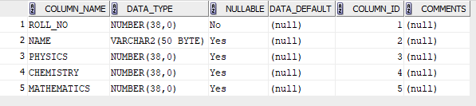

SQL > INSERT INTO STUDENT_35_JIBIN (roll_no, name, physics, chemistry, mathematics)

VALUES (1, 'Adam', 20, 20, 33);

SQL > INSERT INTO STUDENT_35_JIBIN (roll_no, name, physics, chemistry, mathematics)

VALUES (2, 'Bob', 18, 9, 41);

SQL > INSERT INTO STUDENT_35_JIBIN (roll_no, name, physics, chemistry, mathematics)

VALUES (3, 'Bright', 22, 7, 31);

SQL > INSERT INTO STUDENT_35_JIBIN (roll_no, name, physics, chemistry, mathematics)

VALUES (4, 'Duke', 13, 21, 20);

SQL > INSERT INTO STUDENT_35_JIBIN (roll_no, name, physics, chemistry, mathematics)

VALUES (5, 'Elvin', 14, 22, 23);

SQL > INSERT INTO STUDENT_35_JIBIN (roll_no, name, physics, chemistry, mathematics)

VALUES (6, 'Fletcher', 2, 10, 48);

SQL > INSERT INTO STUDENT_35_JIBIN (roll_no, name, physics, chemistry, mathematics)

VALUES (7, 'Georgina', 22, 12, 22);

SQL > INSERT INTO STUDENT_35_JIBIN (roll_no, name, physics, chemistry, mathematics)

VALUES (8, 'Mary', 24, 14, 31);

SQL > INSERT INTO STUDENT_35_JIBIN (roll_no, name, physics, chemistry, mathematics)

VALUES (9, 'Tom', 19,15,24);

SQL > INSERT INTO STUDENT_35_JIBIN (roll_no, name, physics, chemistry, mathematics)

VALUES (10, 'Zack', 8, 20, 36);

SQL > SELECT * FROM STUDENT_35_JIBIN;

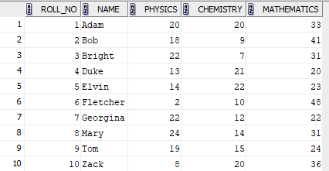

QUESTIONS

1. SELECT AVG(physics) AS class_average_physics FROM STUDENT_35_JIBIN;



1. SELECT MAX(mathematics) AS highest_marks_maths FROM STUDENT_35_JIBIN;



1. SELECT MIN(chemistry) AS lowest_mark_chemistry FROM STUDENT_35_JIBIN;



1. SELECT COUNT(*) AS pass_in_physics FROM STUDENT_35_JIBIN WHERE physics >= 12;



1. SELECT roll_no, name FROM STUDENT_35_JIBIN WHERE physics >= 12 AND chemistry >= 12 AND mathematics >= 25;



1. SELECT roll_no, name, (physics + chemistry + mathematics) AS total_marks, CASE WHEN physics >= 12 AND chemistry >= 12 AND mathematics >= 25 THEN 'Pass' ELSE 'Fail' END AS status FROM STUDENT_35_JIBIN ORDER BY total_marks DESC;

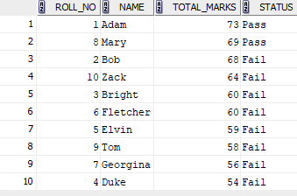

1. SELECT (COUNT(CASE WHEN mathematics>=25 THEN 1 END)*100.00/COUNT(*))AS PASS_PERCENTAGE_MATHS FROM STUDENT_35_JIBIN;



1. SELECT (COUNT(CASE WHEN physics >= 12 AND chemistry >= 12 AND mathematics >= 25 THEN 1 END) * 100.00 / COUNT(*)) AS overall_pass_percentage FROM STUDENT_35_JIBIN;



1. SELECT AVG(physics + chemistry + mathematics) AS class_average FROM STUDENT_35_JIBIN;



1. SELECT COUNT(*) AS total_pass FROM STUDENT_35_JIBIN WHERE physics >= 12 AND chemistry >= 12 AND mathematics >= 25;

